UX Design

Question and Rubric Creation and Management
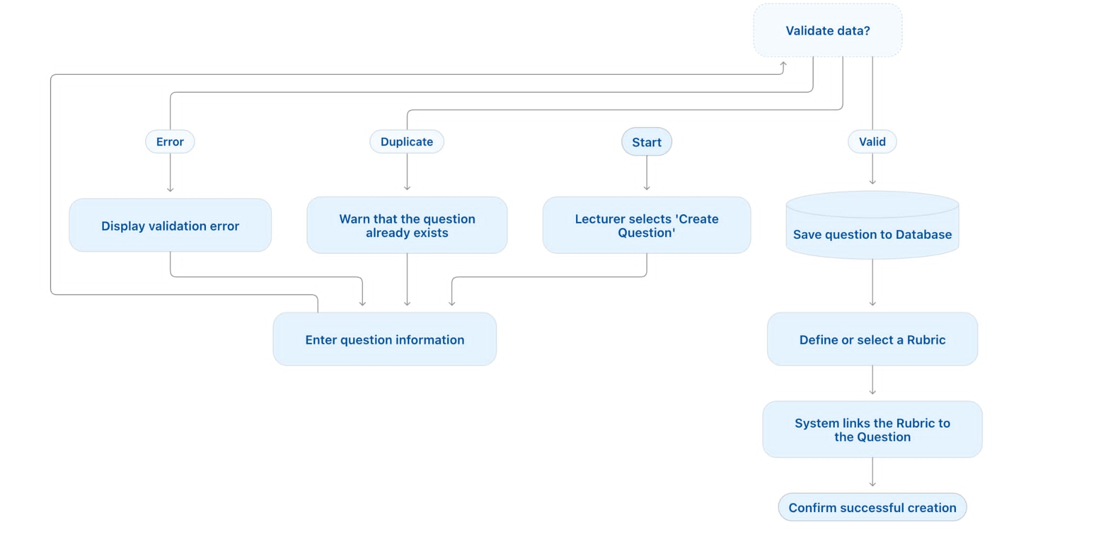

Take the interview with Viva AI
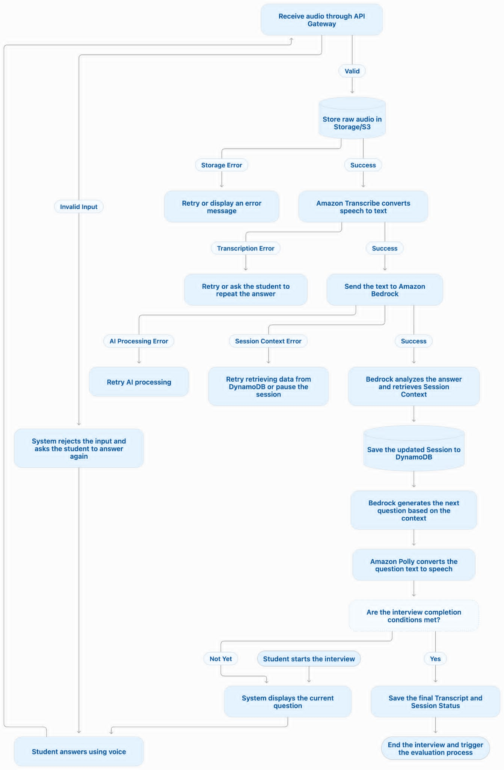

Viva AI Assistant for Scoring and Human-on-the-loop (Lecturer Approval)
